QA Task May 2022

Paul Ireland 25/5/2022  
See GitHub repo: <https://github.com/trashytop/elucidat-finding-the-truth>

# Tasks

## Report 3 bugs you can find in a detailed manner

### First Bug

**Title**: Incorrect case displayed  
**How to recreate**: Use the Start button to explore the cases. Select the “Who is to blame?” case.  
**Expected behaviour**: The “Who is to blame” case should be displayed.  
**Error behaviour**: The “Making a case against Kevin” case is displayed.  
**Notes**: Expected behaviour occurs when you use the “Case 2: WHAT HAPPENED?” item in the hamburger menu.  
**Test Automation**: See BDD Scenario *Selecting a case*  
**Screenshots**:

|  |  |
| --- | --- |
|  |  |
|  |  |

### Second Bug

**Title**: Incorrect verdict confirmed  
**How to recreate**: Use the Start button to explore the cases. Select the “Making a case against Kevin” case. Select “Judge This”. Vote guilty.  
**Expected behaviour**: The guilty verdict should be confirmed.  
**Error behaviour**: The **not** guilty verdict is confirmed.  
**Notes**: Also get guilty verdict confirmed if you vote not guilty.  
**Test Automation**: See BDD Scenario Outline *Voting for a verdict***Screenshots**:

|  |  |
| --- | --- |
|  |  |
|  |  |
|  |  |

### Third Bug

**Title**: Expert’s photo not displayed in “Research Says”  
**How to recreate**: Use the “WHAT THE RESEARCH SAYS” item in the hamburger menu. Click on “The Confession”.   
**Expected behaviour**: A photo of the expert *Dr Trinia Havard* should be displayed.  
**Error behaviour**: A photo of the **victim** is displayed.  
**Notes**: All other research items, e.g. “Eyewitness” show the expert’s photo.  
**Test Automation**: See BDD Scenario Outline *Photo should match the expert* (currently WIP)**Screenshots**:

|  |  |
| --- | --- |
|  |  |
|  |  |

## Write Gherkin scenarios to describe the expected behaviour

See GitHub repo

## Using a test automation framework of your choice, write tests that would test those bugs and help the developer verify their fix is working correctly

See GitHub repo.

# Miscellaneous

## Other bugs found during exploratory testing

* Number of cases offered (2 cases) is inconsistent with number of cases mentioned in the intro from the judge (3 cases)
* Score should be an integer that is either positive or zero, currently shows today’s date, e.g. “Your score so far:5/26/22”
* Spelling/Grammar mistakes, e.g.
  + On “The Eyewitness / The Prosecution” *two witness*, should be *two witnesses*
  + On “What the research says / DNA” victims’ and suspects’ should be victim’s and suspect’s
* Inconsistencies in text formatting, e.g.
  + “What the research says” expert comment has double but personal comment has no quotes

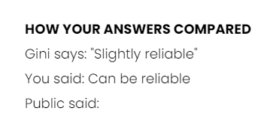

* Inconsistencies in background colours, e.g.
  + “Case Study: Eyewitness” timeline has black background, other case studies have white background



* Debugging in browser console – is this intentional?

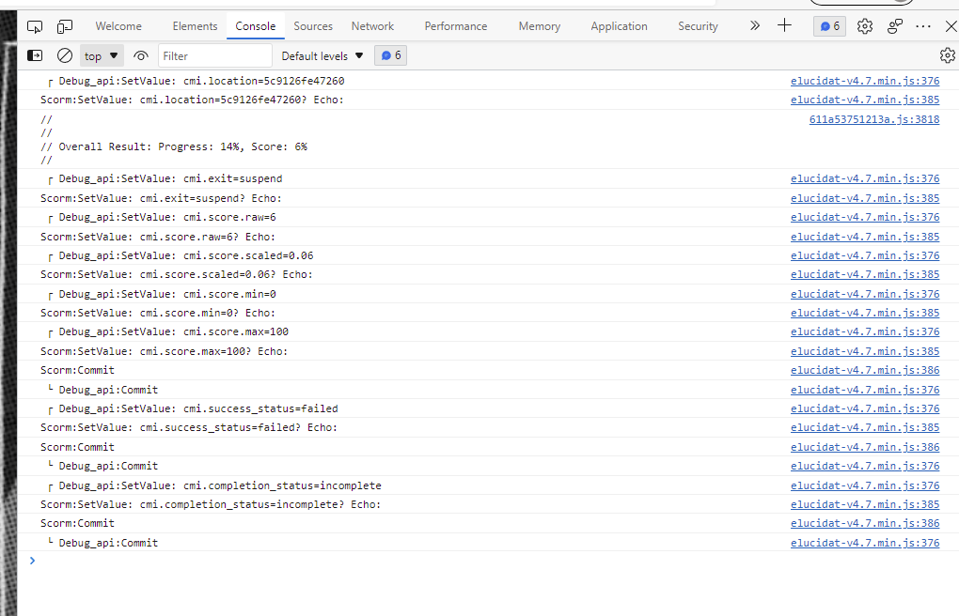

* Hamburger menu is not visible on all pages.

## Browsers and OS

All exploratory testing done on Chrome 101.0.4951.67 on Windows 10.0.19044

Very quick sanity check on Firefox 90.0.2, Edge 101.0.1210.53 on Windows 10.0.19044 and Chrome 101.0.4951.61 on One Plus 5 running OxygenOS version 10.0.1

## Serenity Report (before bugs fixed!)

